

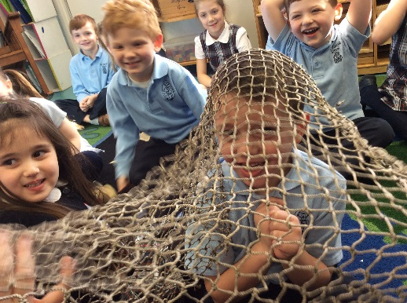

**Religion**: We read a story from the Bible about Peter and Andrew at the sea. Jesus said, “Come follow me and I will make you fishers of men.” Children were caught in our fishing net as a reminder that this is a call to all of us.

**Math:** At the Math Center, we counted by fives (working in base 5 to increase to base 10). When we made 5, we moved it over to the blue side. (The concept of tens and ones is developing)

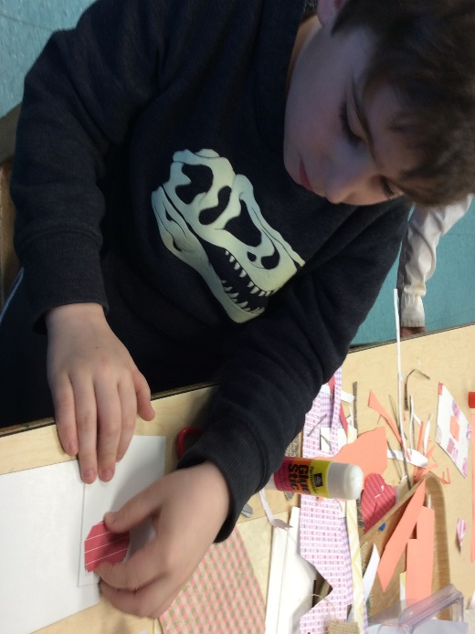

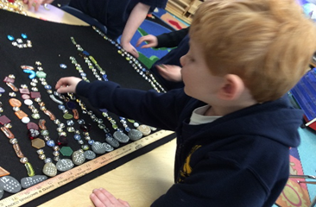

**Atelier**: We made houses and buildings in our neighborhood using shapes.

**Math**: Building number sense and number sequence: First we put the stones in order. Then we put the jewels for the exact number above each stone.

**Listening Center**: At Listening Center we listened to the story, **The Season** in big book and little books. It was about summer, autumn, winter and spring. We had to decide which one we liked and drew and wrote about it. You have to remember to point to words.



**Maker’s Space** (Block Center): We built a water supply tank. Water goes up the tubes to people’s house. We made a ski lift. We used rope, wheels and pulleys. We build train tracks. They start at the bottom and stop on the platform. 

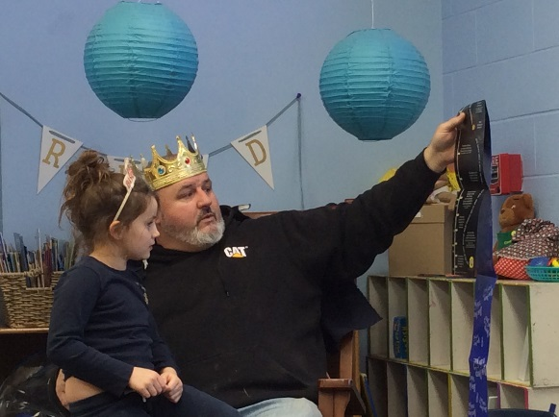

Royal Reader: Mr. LaCroix read, **How Deep is the Sea,** to celebrate Olivia’s birthday.